

Opinion Poll on the Palestinian Government’s Performance against the Coronavirus, SARS-CoV-2 (COVID-19)
Publication date: Tuesday, March 31, 2020
Date of the poll: March 28-31, 2020
Poll sample: 800 economically and socially active Palestinian men and women

Introduction
Arab World for Research and Development (AWRAD) presents to you the results of an opinion poll conducted among Palestinians who are considered socially and politically active (employees of the public, private, civil, and international sector; activists and community leaders; influential people such as those working in the media; university professors; youth activists and leaders of civil and feminist institutions, etc.). The poll revolved around issues related to the current situation that Palestinian society, and the world as a whole, is experiencing. In particular, the poll assesses the actions of the Palestinian National Authority and the role of all relevant bodies and individual coping mechanisms toward the COVID-19 pandemic. AWRAD will periodically monitor developments of opinion among the Palestinians through periodic and specialized surveys, with the aim of contributing to developing governmental and nongovernmental performance in combating the pandemic and enhancing social cohesion.

Survey Methodology
The poll was conducted through an online survey, and it was answered by 800 Palestinians, 77% from the West Bank and 23% from the Gaza Strip. The breakdown of men and women was 57% and 43%, respectively. Of the sample, 30% work in the public sector, 45% in the private sector, 18% in NGOs, and 7% in international institutions. As for age distribution, 30% were 18-30 years old, 51% were 31-50 years old, and 19% were over 50. The questionnaire was presented to a wide sample of socially active Palestinians through social media platforms and groups, while ensuring the largest possible representation of all geographical regions and socio-economic variables. The survey was open for a period of more than 3 days (3/28 to morning of 3/31). There was a notable response to the questionnaire, which is attributable to the importance and urgency of the issue at hand and the widespread belief among people of the significance of their role and providing their opinions in developing the mechanisms to deal with this pandemic.

For more information or clarifications, please contact Dr. Nader Said (0599204527 or nader@awrad.org) or Samer Said (0599846183 or samer@awrad.org). To obtain the results in Arabic and English, visit the AWARD website: www.awrad.org

Highlights
- 82% of respondents evaluate the overall performance of the government of Dr. Shtayyeh positively, an unprecedented high evaluation.
- The positive evaluation of the government of Dr. Shtayyeh is equal in both the West Bank and the Gaza Strip and is also equal for women and men.
- The most positively evaluated measures: closing the educational institutions, asking citizens to pray at home, and the quick response.
- The less positively evaluated measures: dealing with the issue of workers in Israel and the Israeli settlements, workers’ compensation, and insufficient examination centers.
- The respondents gave the Ministry of Health a score of 7 out of 10, the Palestinian media 6.7, NGOs 5.5, and the private sector 4.6.
- 40% of respondents expect an increase in community violence and 33% expect an increase in domestic violence.
- With the onset of the crisis; 10% stated that they had totally lost their jobs and 9% had partially lost them due to the onset of the crisis.
- 30% expect to lose their jobs in the coming time period as the COVID-19 pandemic continues.
- 71% report that family income has declined (significantly or limitedly) due to the pandemic.
- 58% of women report that their household duties have increased, compared to 40% of men.
- 41% of women say that childcare duties have increased, compared to 32% of men.
- 59% of respondents are fully committed to the government’s stay-at-home order.
- 57% do their work (in whole or in part) remotely from home.

Detailed Results
(1) Evaluation of the performance of the government of Dr. Shtayyeh: An unprecedented positive evaluation.
The current results of the evaluation on the general performance of the government of Dr. Shtayyeh have not been matched in opinion polls over the past several years. In this survey, 82% rated performance as positive, 15% as average, and 3% as weak. This is an exceptional increase (55%) from a previous survey conducted by AWRAD at the beginning of 2020, when the percentage of positive evaluation reached 27%. In terms of trust in the government led by Dr. Shtayyeh, 80% confirmed that they trusted his government to deal with the ongoing crisis. The positive evaluation of the performance of Dr. Shtayyeh’s government is equal between the West Bank and the Gaza Strip, as well as between women and men.
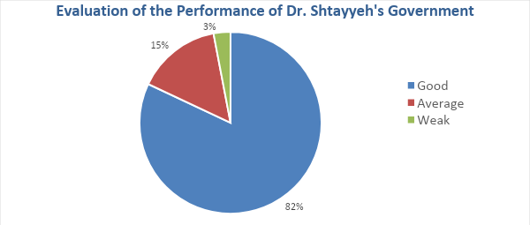
(2) Evaluation of the measures to deal with the COVID-19 pandemic.
Responses to government actions can be categorized into three categories: high positive evaluation, which can be strengthened through attentiveness and sustainability; medium positive evaluation, which needs to be developed; poor evaluation, which needs substantial steps to be dealt with.
Category 1: High positive evaluation
Out of 19 measures, the government received a high positive evaluation for 8 measures, namely: closing educational institutions, asking citizens to pray in their homes, the speed of the government’s actions to contain spread of the disease, closing public places such as cafes and restaurants, transparency in publishing information and data about infection cases, exempting mothers from work, awareness and information programs, and rearranging the working hours of the Palestinian Authority’s employees.
How would you rate the actions of the government under Shtayyeh in regard to the spread of the coronavirus in the following aspects? Was it less than needed, appropriate, or exaggerated?

Table 1: The measure is appropriate (70% or more of respondents believe this): Continue to perform well
 |  | Less than needed | Appropriate | Exaggerated | I don’t know / No answer
1 | Closing educational institutions (nurseries, schools, universities) | 2% | 95% | 3% | --%
2 | Asking citizens to pray in their homes | 4% | 88% | 7% | 1%
3 | The speed of the government’s actions to contain the spread of the disease | 10% | 88% | 1% | 1%
4 | Closing public places such as restaurants and cafes | 14% | 83% | 3% | --%
5 | Transparency in publishing data on infection cases | 13% | 80% | 2% | 5%
6 | Exempting mothers from work | 11% | 80% | 5% | 4%
7 | Awareness and information programs | 23% | 71% | 4% | 2%
8 | Rearranging the working hours of Palestinian Authority staff | 15% | 71% | 2% | 12%

Category 2: Average positive evaluation
Three measures received average positive evaluation, namely: closing certain areas, preventing gatherings, and dealing with issues of the border with Jordan.
Table 2: The measure is appropriate (50%-70% of respondents believe this): Introduce proper adjustments for development
 |  | Less than needed | Appropriate | Exaggerated | I don’t know / No answer
9 | Closing certain areas | 29% | 66% | 2% | 3%
10 | Preventing gatherings | 39% | 58% | 3% | --%
11 | Dealing with issues of the border with Jordan | 36% | 53% | 2% | 9%

Category 3: Measures that need significant development
The respondents considered nine measures requiring major developments, namely: adequacy (availability and quality) of quarantine centers, dealing with the issue of borders with Egypt, adequacy (availability and quality) of examination centers, finding alternatives to school education, dealing with checks and accumulation of debt issues, compensating the unemployed, and compensating businesses. The measure that received the lowest evaluation was clearly the government’s handling of the issue of workers in Israel and settlements, where two-thirds of respondents considered it to be less than needed.
Table 3: The measure is appropriate (less than 50% of respondents believe this): substantial developments are required
 |  | Less than needed | Appropriate | Exaggerated | I don’t know / No answer
12 | Issues of checks and accumulation of debts | 33% | 45% | 4% | 18%
13 | Dealing with issues of the border with Egypt | 35% | 45% | 2% | 18%
14 | Sufficiency (availability and quality) of quarantine centers | 44% | 48% | --% | 8%
15 | Finding alternatives to school education (distance education) | 44% | 43% | 6% | 7%
16 | Sufficiency (availability and quality) of examination centers | 49% | 42% | --% | 9%
17 | Compensation for businesses | 45% | 22% | 3% | 30%
18 | Compensation for the unemployed | 63% | 23% | 1% | 13%
19 | Dealing with the issue of workers in Israel and settlements | 67% | 26% | 3% | 4%

Most Highly Evaluated Measures

Closing educational institutions
Asking citizens to pray in their homes
The speed of the government's response to the crisis

Measures Needing Most Development

Dealing with issues of workers in Israel and settlements
Compensation for the unemployed
Availability of examination centers
(3) Evaluation of relevant parties
In the survey, the role of relevant actors was evaluated, and as it was previously mentioned, the role of the government led by Dr. Shtayyeh is the highest among all parties evaluated. As for the rest of the parties, the evaluation was as follows: The Ministry of Health ranked second, followed by the Palestinian media as a whole, then Palestinian TV in specific. After that came the performance of NGOs, and then authorities in the Gaza Strip. The evaluation was the least positive for the private sector.
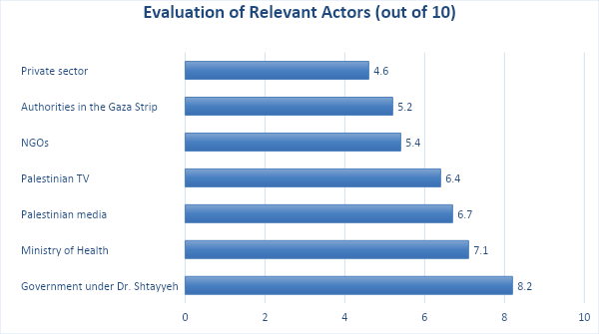

(4) Future expectations
The majority view the future with a pessimistic view regarding economic and educational conditions. There are also fears of increasing household burdens on women, worsening social problems such as violence and crime, and increasing domestic violence against children and women. The survey showed that women are more afraid than men about increasing rates of societal violence (42% to 35%), violence against women (41%, 29%), and violence against children (40%, 31%).
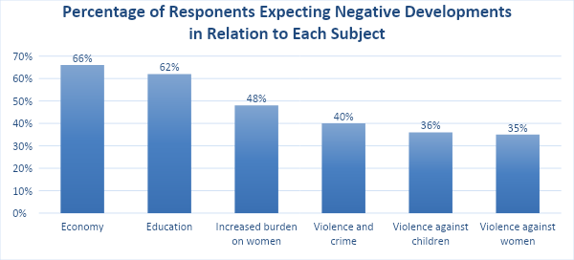

(5) Individual coping with the crisis
In the poll, Palestinians (who were mostly workers and active) were asked about their adaptation and coping with the pandemic:
- 59% said that they are committed to the stay-at-home order by the government, while 34% said that they are committed to some extent, and 6% are not committed. Women were more committed to staying at home (70%) than men (51.3%).
- Upon the onset of the crisis, half of the respondents stated that they have witnessed a decline in family income, and 21% reported that that applies to them to some extent. Also, indications of the looming economic crisis indicate that 10% completely lost their jobs early in the crisis, and 9% lost their jobs partially. Moreover, 30% said that they may lose their jobs in the coming time period. The percentage of men who stated that they had lost their jobs completely was less (8.1%) than that of women (11.5%).
- 47% said that household duties have increased since they have been at home, and 29% said that they have somewhat increased. At the same time, 35% stated that the tasks of caring for children had increased, and 24% said that they had somewhat increased. The percentage varied between women and men, with 58% of women declaring that household duties had increased, while 40% of men said so.
- In addition, 40% stated that they perform their job-related work from home, and 17% reported that this statement somewhat applies to them. 43% reported that they decided to stop going to work to protect themselves, and 18% did so partially. 35.8% of men stated that they do their office work from home, while 46.4% of women said so.
At this time, do the following statements apply to you personally?
 |  | Apply | Somewhat apply | Do not apply | Don’t know / no answer
1 | I am committed to the government stay-at-home order | 59% | 34% | 6% | 1%
2 | I quarantined myself at home | 54% | 34% | 11% | 1%
3 | Family income has decreased due to the crisis | 50% | 21% | 27% | 2%
4 | My household duties have increased while I’ve been at home | 47% | 29% | 23% | 1%
5 | I have not gone to work by my will to protect myself | 43% | 18% | 36% | 3%
6 | I do my work from home instead of the workplace | 40% | 17% | 40% | 3%
7 | My tasks taking care of children have increased | 35% | 24% | 36% | 5%
8 | I may lose my job in the coming time period | 14% | 15% | 63% | 8%
9 | I lost my job due to the coronavirus crisis | 9% | 9% | 78% | 4%

